{CLUB NAME} Child Wellbeing & Protection Policy

[Club name] VOLLEYBALL CLUB acknowledges its responsibility to protect and safeguard the welfare of all children in [club name] from harm.

[Club name] VOLLEYBALL CLUB recognises that all children have the right to participate in volleyball in a safe, enjoyable and positive environment whilst at the same time being protected from abuse, neglect or poor practice.

[Club name] VOLLEYBALL CLUB confirms that it adheres to the Scottish Volleyball Safeguarding Policy and the procedures, guidelines, and practices contained in that document and any successor policy.

[Club name] confirms that it will appoint a Child Wellbeing & Protection Officer (CWPO) at the club. Their details will be available within the Scottish Volleyball database. The SWO will undergo Safeguarding training as directed by Scottish Volleyball.

The [club name] CWPO is [ ] and they agree to be contacted with any concerns regarding child protection and safeguarding and will take appropriate action.

[Club name] VOLLEYBALL CLUB agrees that all allegations or suspicions of abuse, neglect, harm or poor practice will be taken seriously and responded to swiftly, fairly and appropriately.

[Club name] VOLLEYBALL CLUB recognises that all children have the right to expect that their participation in volleyball will be supported and delivered by suitably recruited, vetted and managed staff, whether they are volunteering or officiating.

All members of [club name] VOLLEYBALL CLUB who undertake regulated work must be member of the PVG Scheme with a Scheme Record Update if necessary.

{Club name} acknowledges the Disclosure Scotland referrals process and agrees to action a referral if required.

[club name} agrees that any trips, overseas or domestic must comply with the relevant Scottish Volleyball regulations and Guidance relating to trips.

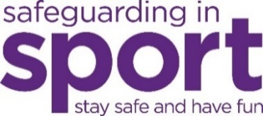
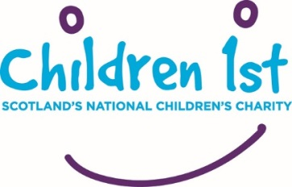
Signed on [Add Date}

Club President / Chairperson Child Wellbeing & Protection Officer

